**Project Write-up**

DESCRIPTION

**Project objective:**

As a developer, write a program to search a string entered by a user from the array of strings.

**Background of the problem statement:**

You have an array of email IDs of employees. As a programmer, write a program to search the email ID entered by a user.

**Validation of an Email ID .**

**package** Validation_Of_Email;

**import** java.util.ArrayList;

**import** java.util.List;

**import** java.util.Scanner;

**import** java.util.regex.Matcher;

**import** java.util.regex.Pattern;

**public** **class** ValidationOfEmail {

**public** **static** **boolean** isValidEmail(String email) {

String regex = "^(.+)@(.+)$";

//initialize the Pattern object

Pattern pattern = Pattern.*compile*(regex);

Matcher matcher = pattern.matcher(email);

**return** matcher.matches();

}

**public** **static** **void** main(String[] args) {

List<String> emails = **new** ArrayList<String>();

// valid email addresses

emails.add("sasank@example.com");

emails.add("sasankreddy@example.com");

emails.add("sasa@example.me.org");

//invalid email addresses

emails.add("asan.example.com");

emails.add("akil..bob@example.com");

emails.add("reddy@.example.com");

**for** (String value : emails) {

System.***out***.println("The Email address " + value + " is " + (*isValidEmail*(value) ? "valid" : "invalid"));

}

System.***out***.println("Enter any email address to check");

Scanner sc = **new** Scanner(System.***in***);

String input = sc.nextLine();

System.***out***.println("The Email address " + input + " is " + (*isValidEmail*(input) ? "valid" : "invalid"));

}

}

**Output:**

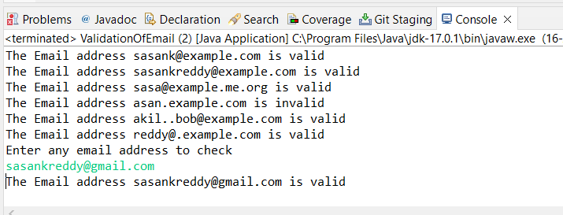

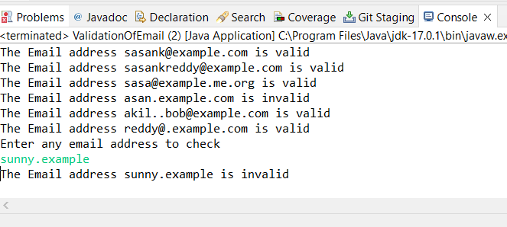

Pushing the code to your GitHub repositories

* Open your command prompt and navigate to the folder where you have created your files.

**cd <folder path>**

* Initialize your repository using the following command:

**git init**

* Add all the files to your git repository using the following command:

**git add .**

* Commit the changes using the following command:

**git commit . -m “Changes have been committed.”**

* Push the files to the folder you initially created using the following command:

**git push -u origin master**